# BMS Data Analysis

**Description**: Max Fordham Engineers have connected to Kings College BMS system and pulled the data from the server. The analysis below is a summary of the data extracted…

**Job Name**: Kings College

**Job Number**: J6150

**Engineer**: JG

**Filename**: 6150_bms-data-monitoring

**Working Directory**:

**Rev**: *

**Date**: None

Table of Contents

BMS Data Analysis 1

Context 3

Data extractred from the gbXML model used for energy simulations 4

Constructions Data 5

Summary 5

Spaces Data 5

Part L BRUKL Compliance Data 6

Selected Data from Passivhaus Analysis Spreadsheet 7

In-Use Monitoring Data 8

Data Pre-processing: 8

Grouping of Loads 8

Main Analysis 9

Usage by load type 9

Load Dynamics 10

Heating Loads 12

Domestic Hot Water 14

Load Types Analysis 17

### Context

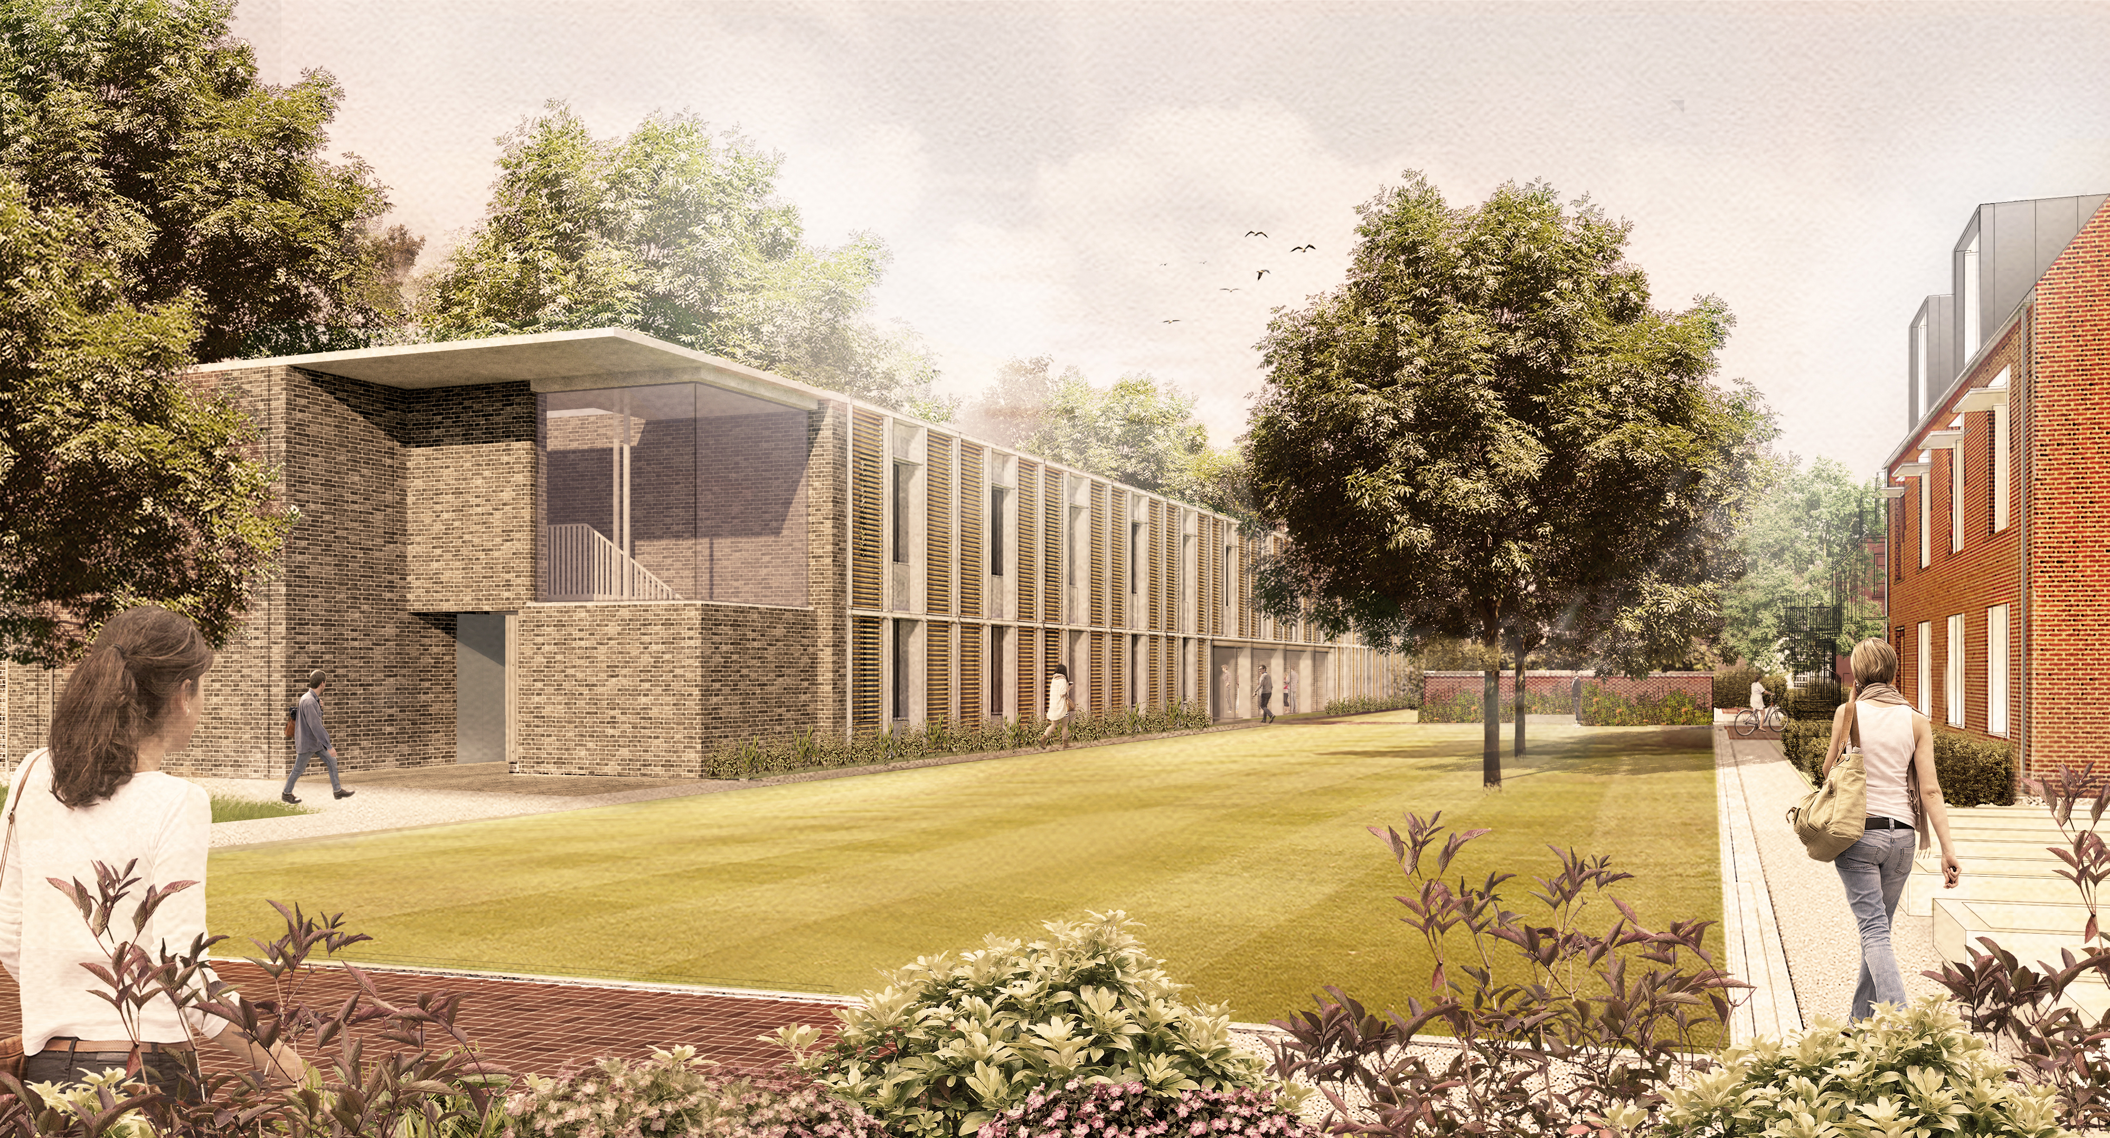

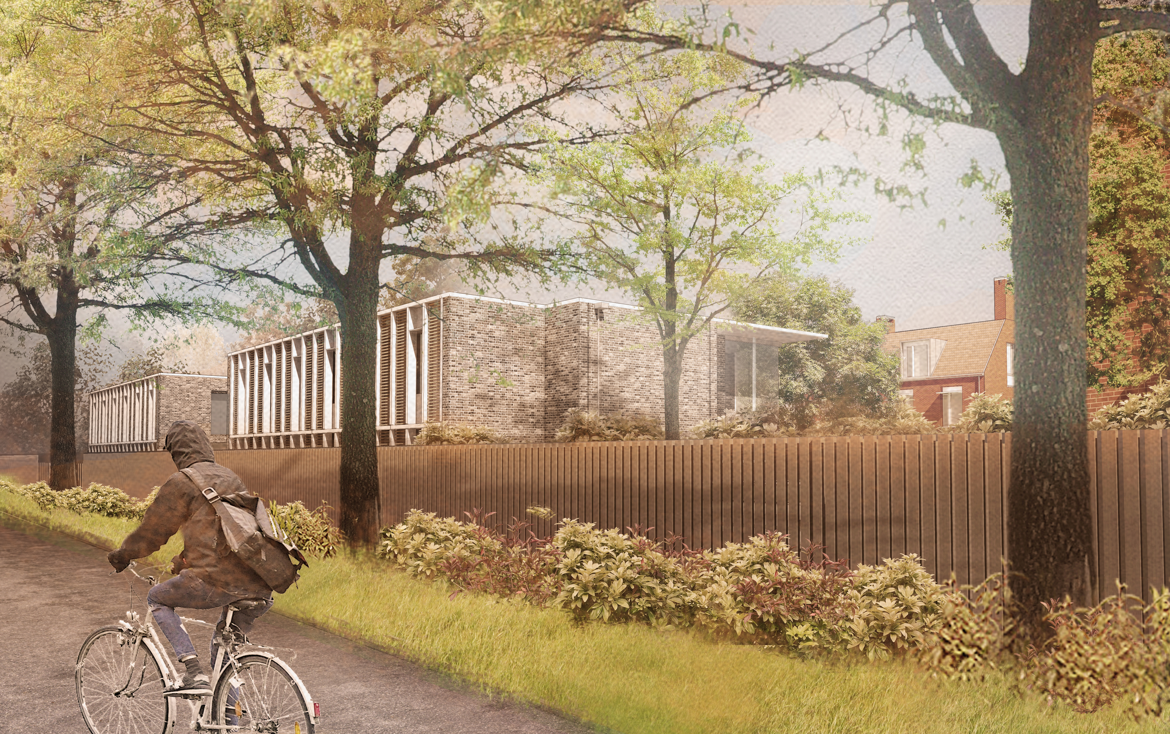

## Data extractred from the gbXML model used for energy simulations

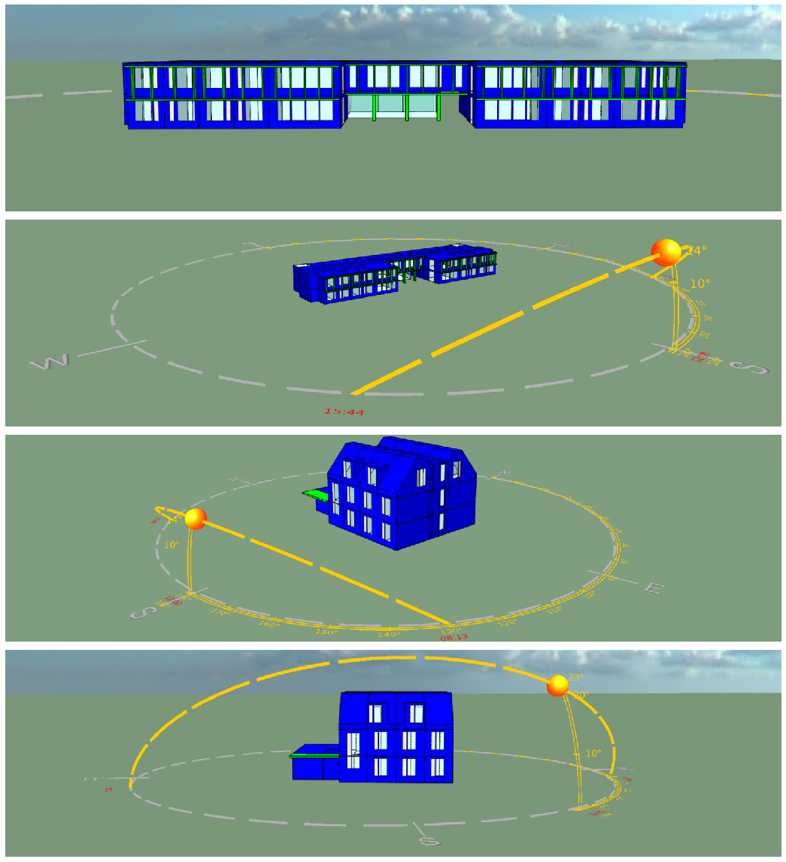

### Constructions Data

### Summary

|  |  |  |
| --- | --- | --- |
| @id | Name | U-value_WPerSquareMeterK |
| STD_CEIL | CLT Soffit/Floor | 1.02 |
| STD_DOOR | Vent Panel | 1.03 |
| STD_FLO2 | Ground Floor | 0.1 |
| STD_PART | 2013 Internal Partition | 1.79 |
| STD_ROOF | CLT Roof | 0.12 |
| WALL | CLT Wall | 0.1 |
| STD_EXTW | Triple Glazed Window | 1.19 |
| STD_RFLT | Rooflight | 0.85 |

### Spaces Data

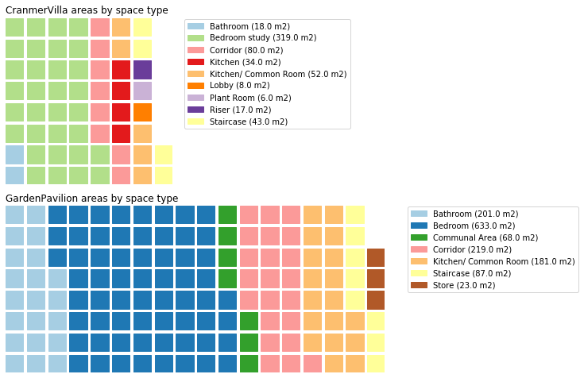

### Part L BRUKL Compliance Data

Inp files that contain Part L Compliance BRUKL data:

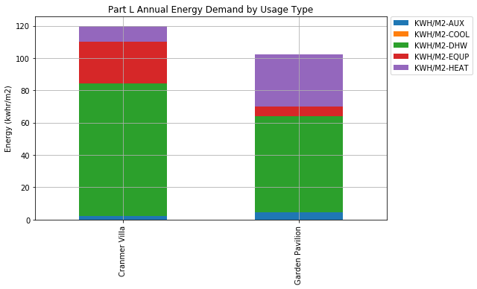

## Selected Data from Passivhaus Analysis Spreadsheet

|  |  |  |  |
| --- | --- | --- | --- |
| description | GardenPavillion-value | VillaBuilding-value | units |
| Internal heat gains | 2.11 | 3.05 | w/m2 |
| Ventilation type | 1-Balanced PH ventilation with HR | 1-Balanced PH ventilation with HR | nan |
| Design air flow rate (maximum) | 1063.58 | 473.1 | nan |
| Ventilation unit selection | 97ud-Default HRV unit | 02ud-Zehnder - ComfoAir Q600 HRV, Comfort Vent Q600 HRV | nan |
| Supply air per person | 30.0 | 30.0 | nan |
| Air change rate at press. test | 0.6 | 0.6 | nan |
| Room height h | 2.5 | 2.5 | m |
| Occupancy definition type | 2-User determined | 2-User determined | nan |
| Year of construction | 2019.0 | 2019.0 | nan |
| Building type | 1-Residential building | 1-Residential building | nan |
| Interior temperature winter | 20.0 | 20.0 | degC |
| Internal Gains Utilisation pattern | 11-Nursing home / students | 11-Nursing home / students | nan |
| Occupancy number of people | 33.2 | 15.77 | no_ppl |
| Building energy standard | 1-Passive House | 1-Passive House | nan |
| Treated floor area | 1090.85 | 434.82 | m2 |
| Effective heat recovery efficiency unit | 0.85 | 0.85 | nan |
| Building envelope to exterior air1 (U-value) | 0.11 | 0.11 | W/(m2K) |
| Building envelope to ground1 (U-value) | 0.16 | 0.17 | W/(m2K) |
| Annual Electricity demand | 27.67 | 35.1 | kWh/(m2a) |
| Annual Heating Demand | 19.23 | nan | kWh/(m2a) |
| Heating Space Heating demand | 17.78 | nan | kWh/(m2a) |
| Performance ratio of heat distribution | 1.0 | 1.0 | ratio |
| Infiltration air change rate: For heating load | 0.11 | 0.11 | nan |
| Infiltration air change rate: For annual demand | 0.04 | 0.04 | nan |
| Internal heat gains (IHG) heating case | 2.11 | 3.05 | W/m2 |
| Climate zone | 3: Cool-temperate | 3: Cool-temperate | nan |
| Cooling load | - | - | W/m2 |
| Pressurization test result n50 | 0.6 | 0.6 | 1/h |
| Average air change rate | 0.58 | nan | nan |
| Average air flow rate | 1573.61 | 635.8 | nan |
| Effective useful heat DHW | 8.49 | 10.72 | kWh/(m2a) |
| PE demand | 166.98 | 185.25 | kWh/(m2a) |
| Total heating demand of DHW system Including storage tank | 8.94 | 11.41 | kWh/(m2a) |
| Average therm. Envelope Y value | 0.21 | 0.22 | Y [W/(mK)] |
| U - Value - Windows (UW,installed) vertical | 0.81 | 0.84 | W/(m2K) |
| Heat losses of DHW distribution and storage | 0.44 | 0.69 | kWh/(m2a) |
| Performance ratio DHW-distribution + storage | 1.05 | 1.06 | ratio |
| Interior temp. summer | 25.0 | 25.0 | degC |

## In-Use Monitoring Data

**Credentials**:

* url: <https://kingscollege.bms.systems/comx-garden-villa/>
* MF working directory: C:_mf6150_bms-data-monitoring

### Data Pre-processing:

#### DB references:

Array of all unique DB references.  
Matches up with what is on the Electrical Schematics:

* [MBS103-V[20]150-Rev4](DesignInfo/ElectricalSchematics/MBS103-V%5B20%5D150-Rev4.pdf)
* [MBS103-V[20]151-Rev4](DesignInfo/ElectricalSchematics/MBS103-V%5B20%5D151-Rev4.pdf)

BD-V-0-02 appears to be a mistake. (should say DB-V-0-02).

**Nomenclature**: [0]-[1]-[2]-[3]

[0] –> equipType

[1] –> db_building

[2] –> db_level

[3] –> db_sequence

### Grouping of Loads

|  |  |  |
| --- | --- | --- |
| ld_typ | ld_serves | ld_ref |
| DHW | West Water Heaters, West Water Heaters, East Water Heaters, East Water Heaters, Water Heaters, Water Heaters, Water Heaters, | DB-G-0-03, DB-G-1-02, DB-G-0-07, DB-G-1-05, DB-V-0-04, DB-V-1-04, DB-V-2-04, |
| Heating | West Panel Heaters, West Panel Heaters, East Panel Heaters, East Panel Heaters, Panel Heaters, Panel Heaters, Panel Heaters, | DB-G-0-03, DB-G-1-02, DB-G-0-07, DB-G-1-05, DB-V-0-04, DB-V-1-04, DB-V-2-04, |
| Kitchen | Kitchen, Kitchen, Kitchen, West Kitchen & Corridor, West Kitchen & Corridor, East Kitchen & Corridor, East Kitchen & Corridor, | BD-V-0-02, DB-V-1-02, DB-V-2-02, DB-G-0-04, DB-G-1-03, DB-G-0-06, DB-G-1-07, |
| Lighting | West Lighting, West Lighting, East Lighting, East Lighting, External Lighting, External Lighting, Lighting, Lighting, Lighting, | DB-G-0-02, DB-G-1-04, DB-G-0-08, DB-G-1-06, DB-G-0-09, DB-V-0-01, DB-V-0-03, DB-V-1-01, DB-V-2-01, |
| Plantroom | East Plantroom, | DB-G-1-08, |
| Power | West Power, West Power, Power, Power, Power, Power, East Power, | DB-G-0-02, DB-G-1-04, DB-G-0-08, DB-V-0-03, DB-V-1-01, DB-V-2-01, DB-G-1-06, |

## Main Analysis

### Usage by load type

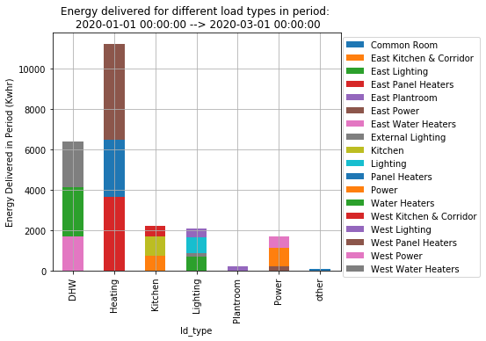

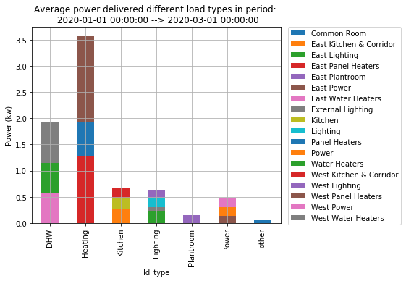

### Load Dynamics

#### Histograms demonstrating number of minutes spent at a given load by load type

The graphs indicate load variability, y-axis is number of minutes and x-axis is power demand (kw).  
It can be seen that “plant-room” and “other” loads run almost continuously at a low power.  
“Heating” on the other hand operates at higher loads but for less time.  
Surprising, the “Kitchen” loads and “DHW” loads operate at a high-frequency.

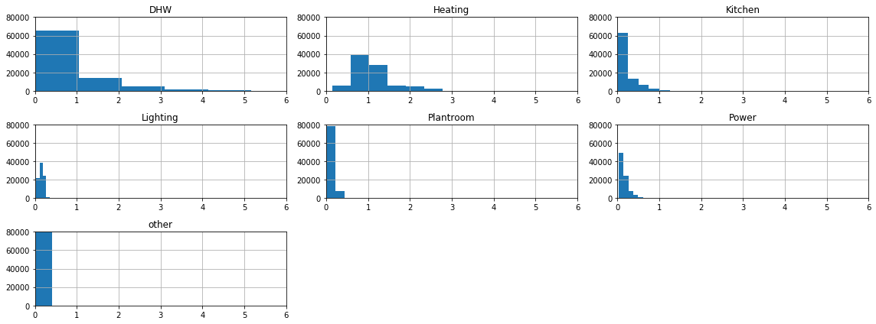

#### A 2-day snapshot in time

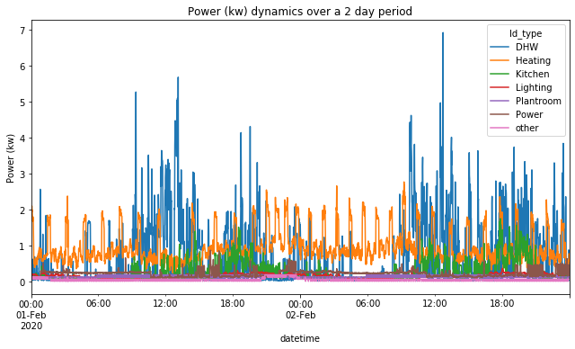

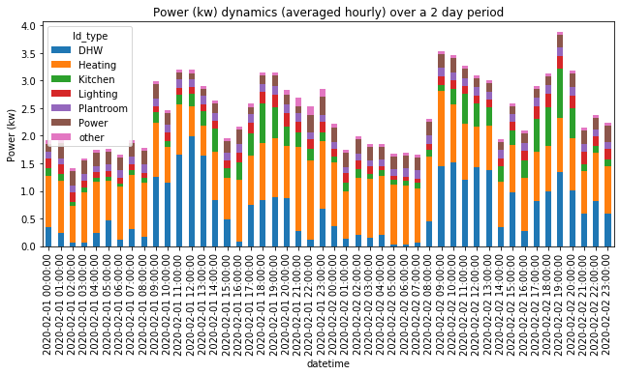

### Heating Loads

#### ??? WHAT IS THE M2 AREA BEING SERVED BY EACH SPACE HEATING BOARD ???

#### Heating plant operation during the peak heating day

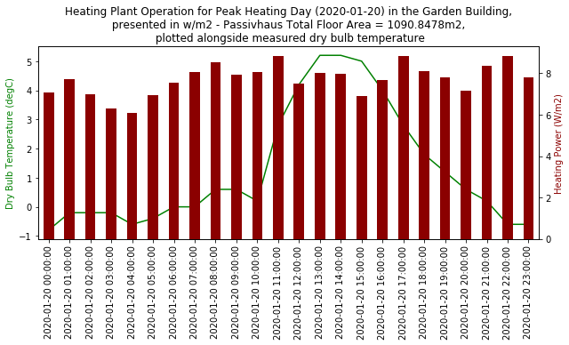

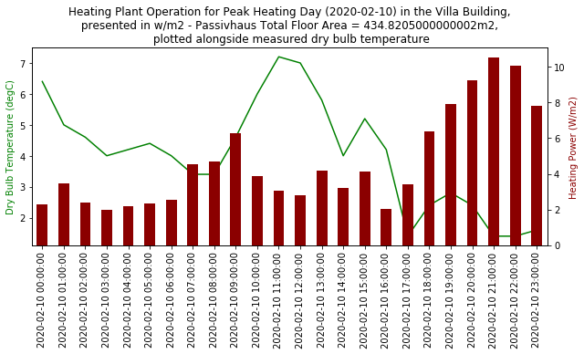

#### Comparison of in-use heating usage to Passivhaus design assumptions

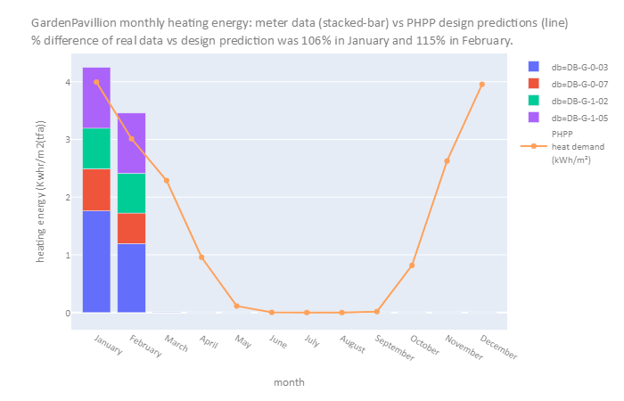

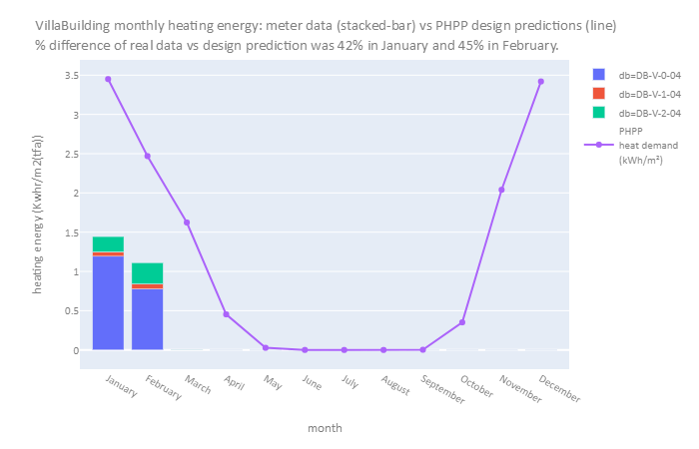

### Domestic Hot Water

#### ??? WHAT IS THE CONNECTED LOAD OF APPLIANCES SERVED BY EACH DHW BOARD ???

#### Passivhaus annual estimated domestic hot water energy use:

Current usage patterns indicate a much larger annual energy use than predicted

|  |  |  |  |  |
| --- | --- | --- | --- | --- |
| name | Total heating demand of DHW system Including storage tank kWh/(m2a) | 2month metered DHW usage kWh/(m2) | projected annual DHW usage kWh/(m2a) | factor over estimate |
| GardenPavillion-value | 8.94 | 3.6 | 21.61 | 2.41723 |
| VillaBuilding-value | 11.41 | 5.6 | 33.63 | 2.94741 |

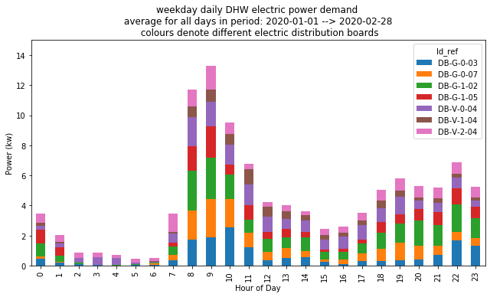

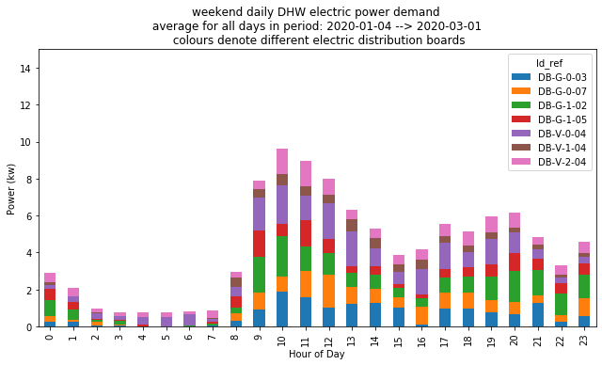

#### Understand DHW peaks

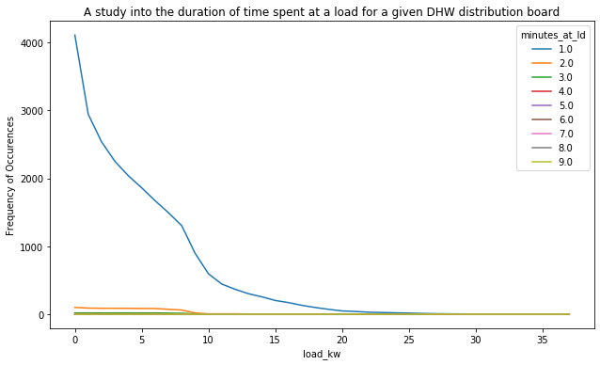

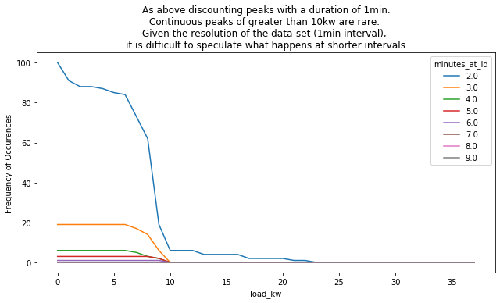

### Load Types Analysis

|  |  |  |  |  |  |  |  |
| --- | --- | --- | --- | --- | --- | --- | --- |
|  | DHW | Heating | Kitchen | Lighting | Plantroom | Power | other |
| Max Power Demand (W/m2(phpp)) - 1min interal | 47 | 21 | 11 | 5 | 1 | 5 | 3 |
| Max Power Demand (W/m2(phpp)) - 1hr interal | 15 | 9 | 5 | 3 | 0 | 3 | 1 |

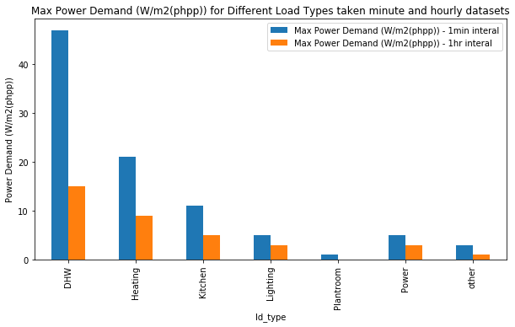

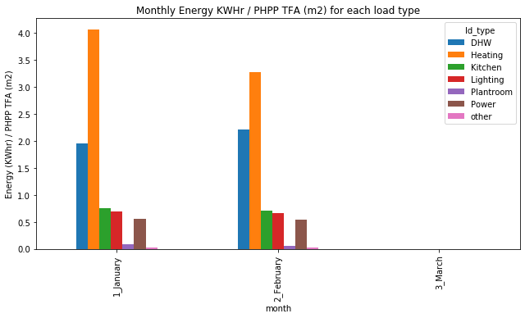

Monthly Energy KWHr / PHPP TFA (m2) for each load type

|  |  |  |  |  |  |  |  |
| --- | --- | --- | --- | --- | --- | --- | --- |
| month | DHW | Heating | Kitchen | Lighting | Plantroom | Power | other |
| 1_January | 1.96 | 4.07 | 0.75 | 0.69 | 0.08 | 0.56 | 0.03 |
| 2_February | 2.21 | 3.27 | 0.71 | 0.66 | 0.06 | 0.54 | 0.03 |
| 3_March | 0 | 0 | 0 | 0 | 0 | 0 | 0 |

'data\\processed\\CompiledOutputsSummary.xlsx'